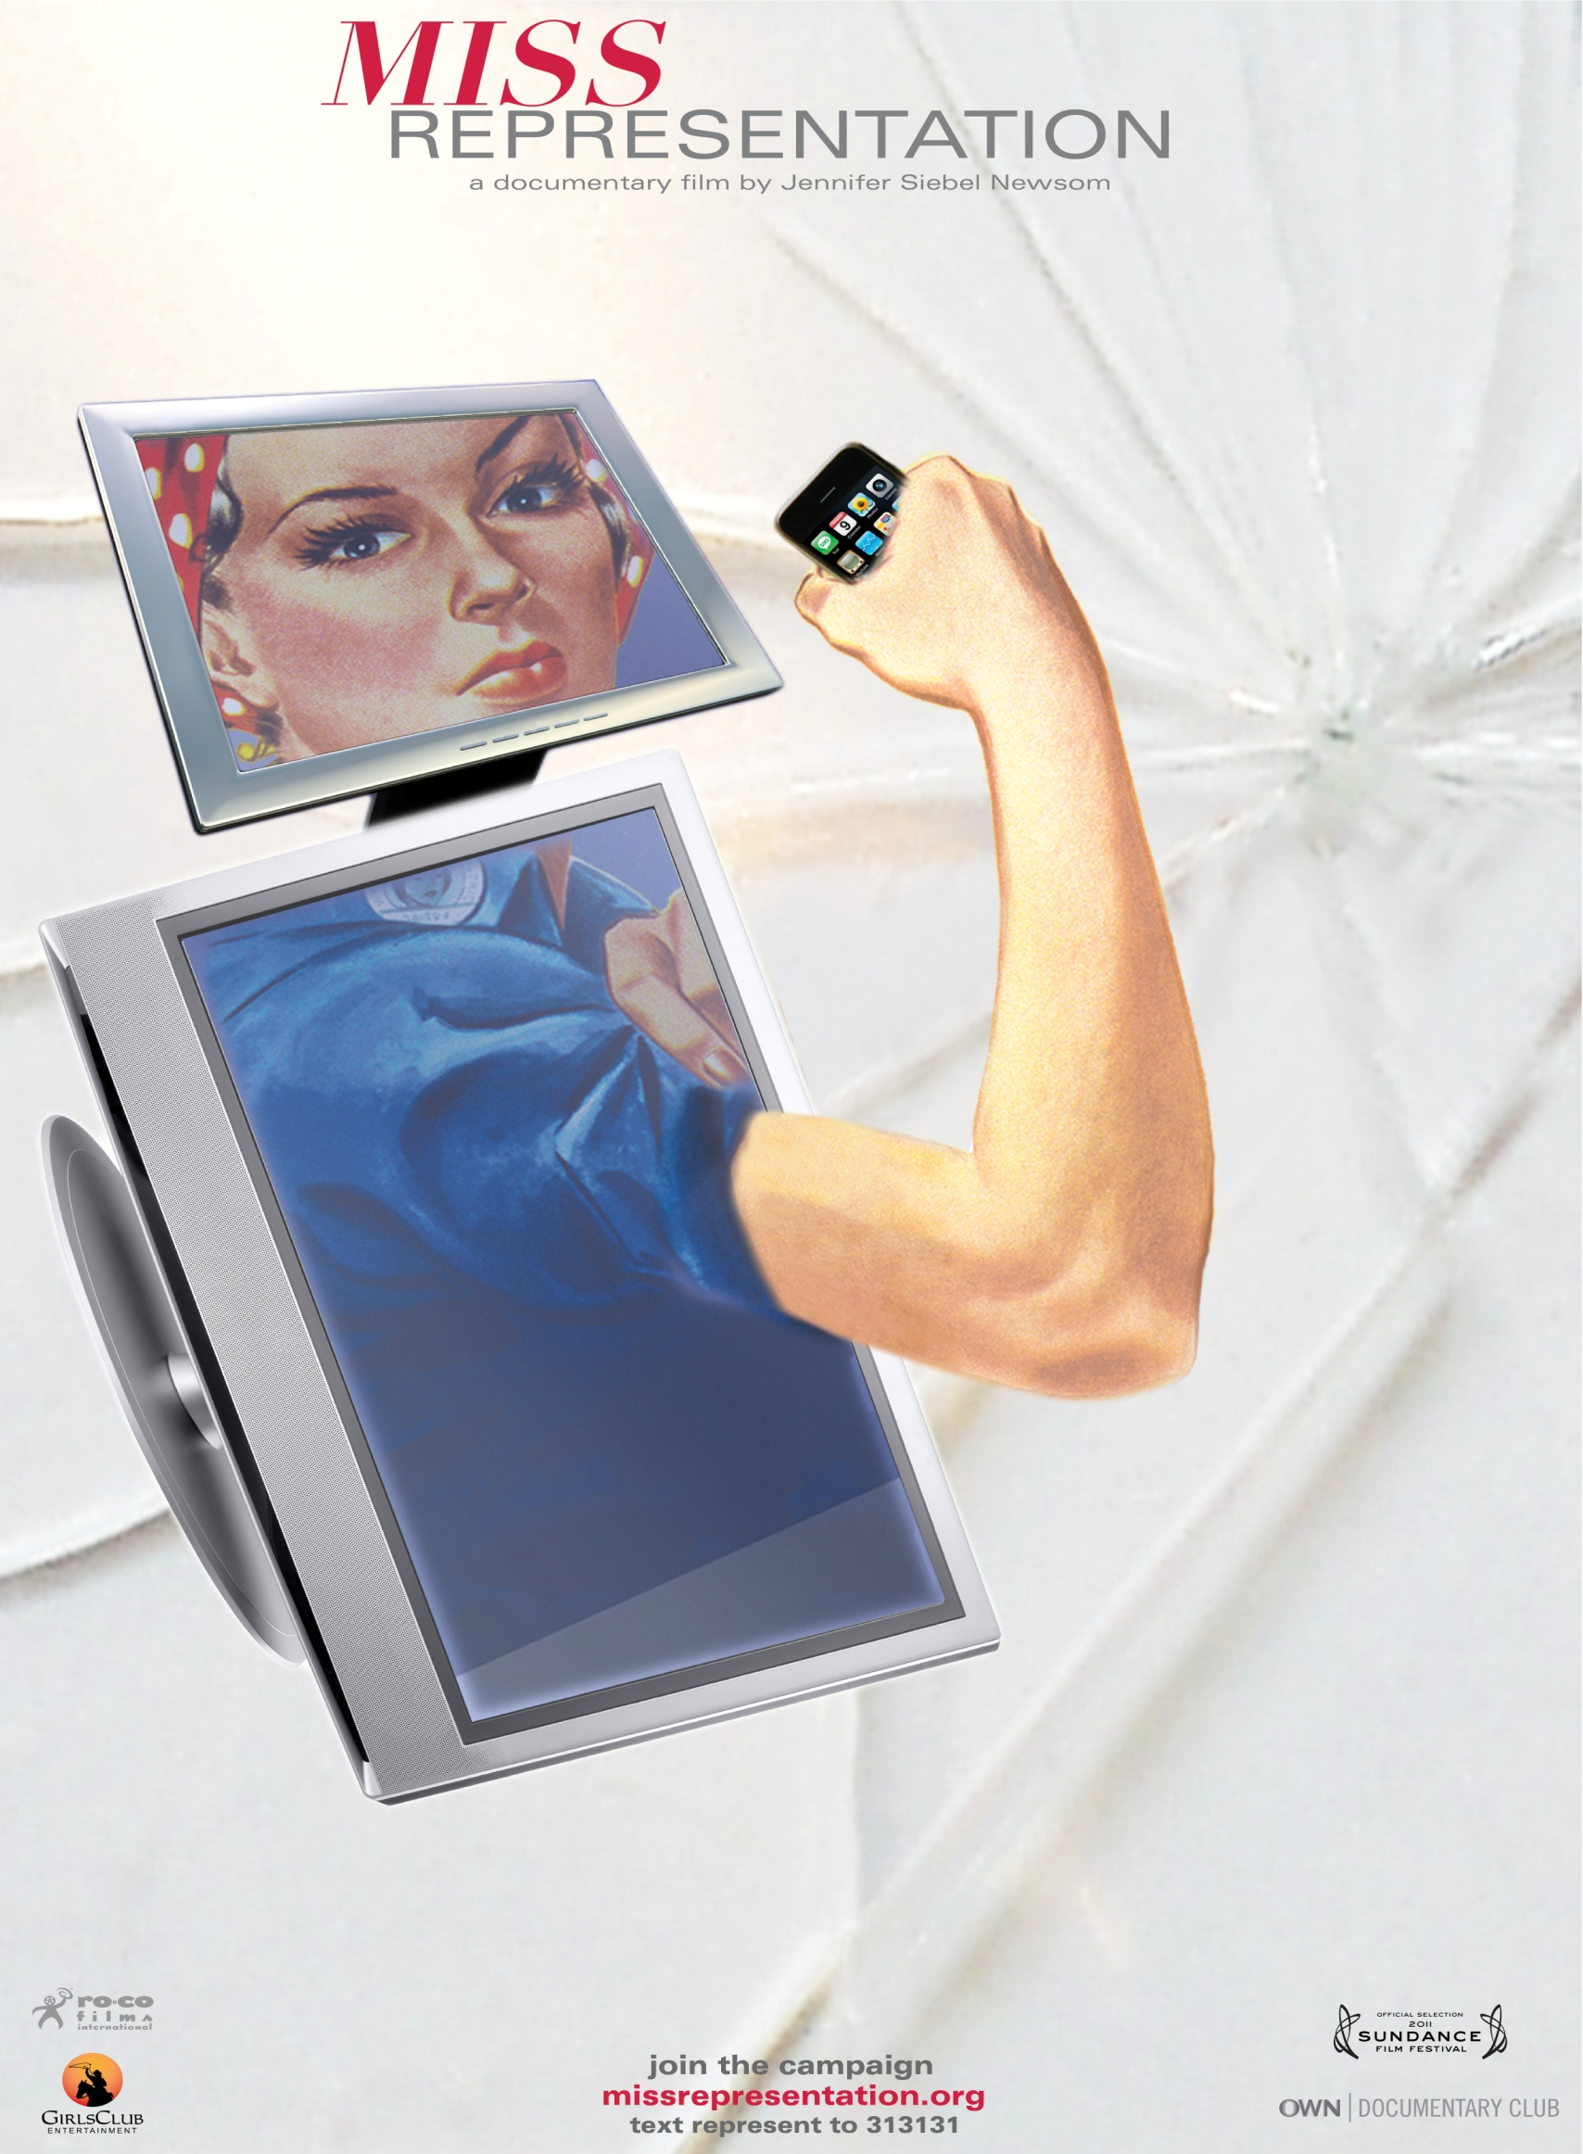

FHS and FYA present:

**This documentary is about how women are often misrepresented in the media and in society. The film highlights the continued inequality of women in many areas of life, including salary, body image, and sense of security.**

**Giveaways for Students!**

**Light Refreshments Will Be Served!**

**RSVP to Ferndale Youth Assistance: 248-586-8700**

**Where: Ferndale High School Media Center**

**Who: High School Girls, Their Parents, and Interested Community Members**

**When: Monday, Oct. 28, 2013**

**Time: 6:00 p.m.**

**Join us for a FREE film viewing and discussion of**

**“Miss Representation”**

